**Setting up application environment**

1. **Docker CLI Installation**

**Team Id** : PNT2022TMID35190

**Project Name** : Skill / Job Recommender Application

**Step 1:** Go the official Docker website: https://docs.docker.com/desktop/install/windowsinstall/

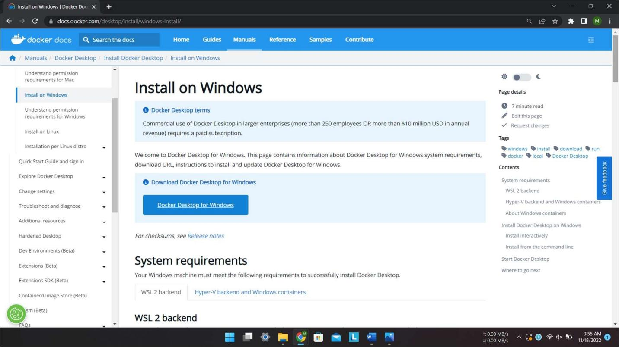

**Step 2:** Click that button (Docker Desktop for Windows) and download will start and it takes few minutes to complete.

**Step 3:** Go to downloads in browser (or) type ctrl + J, it will navigate to download page and double-click the particular docker file.

**Step 4:** Now Installation is complete. This icon was added in your desktop. Go to hub.docker.com register and create an account and login with the same.

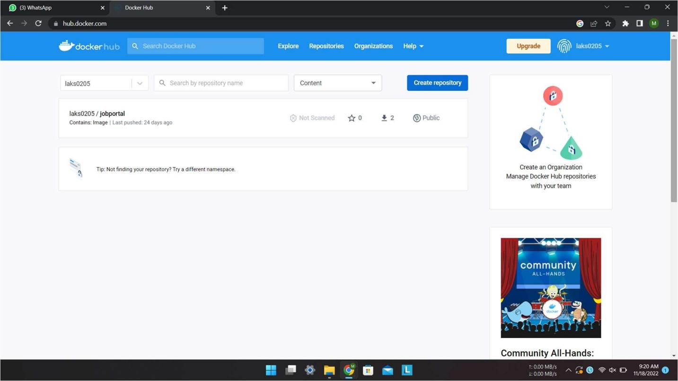

**Step 4:** Double-click the icon to start the docker app, you can register and login that app to access those credentials. Docker will start correctly, the left bottom side was shown in green color, docker will show the status of docker app working successfully.

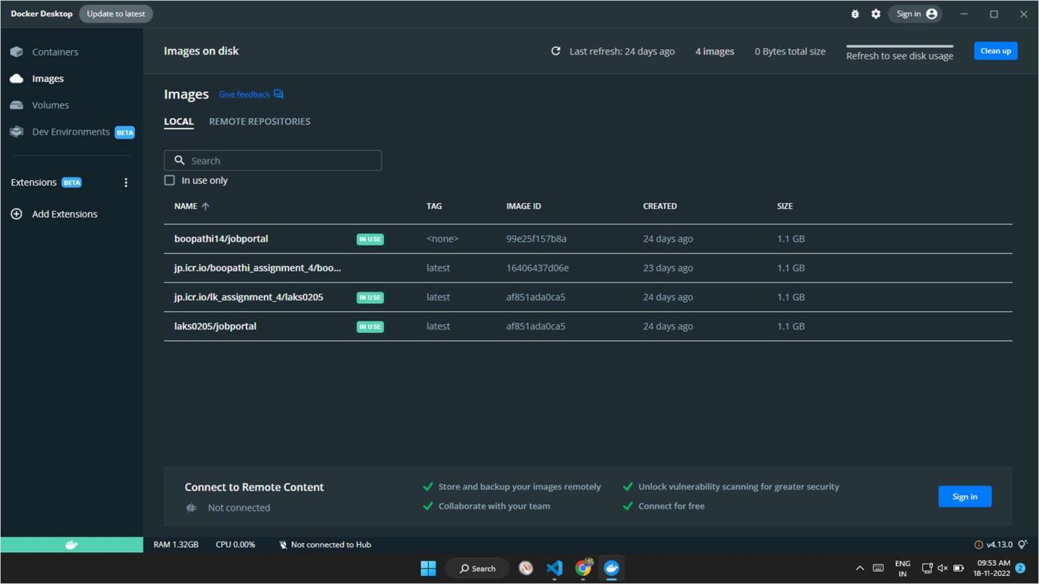

**Step 6:** Finally, the docker is installed successfully